5-24-2015

Got dac.py working.
Tested 440Hz, Fs=2kHz, K = 1,32. 8bit unsigned. Just speaker LPF is enough for K=32 to sound great (and sound card output, I suppose).
Possible issue: K=32/DAC generates many harmonics that I can't see in the input - because I'm sampling the input at Fs, not Fs*K, so it cuts off. A true comparison would be the input, sampled at Fs, then oversampled at Fs*K.

Regardless, we can see that the SD-DAC FFT noise profile is 'shaped', at K=64,
to ~1% of the magnitude of the peak, at 440Hz, which was an input sinusoid taking up the entire 8bit width.

So we have >>40dB SNR with K=64 at 440Hz, and a rough estimate assuming noise stays the same regardless of driving frequency in this range (untested) is that if we had an input sinusoid at 20kHz with amplitude 1/20th (5%) (255/20 ~ 260/20 ~13) that of the 440Hz signal, then we'd still be able to hear it all right (4x ~ 5 dB SNR).

Ok, let's try it - change Fs to 40KHz, keep K at 64, and change duration to 2s/20 = 0.1s so the # samples stays the same. Make the input a near full amplitude 440Hz wave (0-80% 0f 255) and a 1/20th amplitude 10kHz wave (0-13) Then keep the lenDFTs and all the same (at 440Hz, 10kHz we still get plenty of full cycles), and let's see what it 1) looks like, 2) looks like in FFT vs. noise, and 3) sounds like.

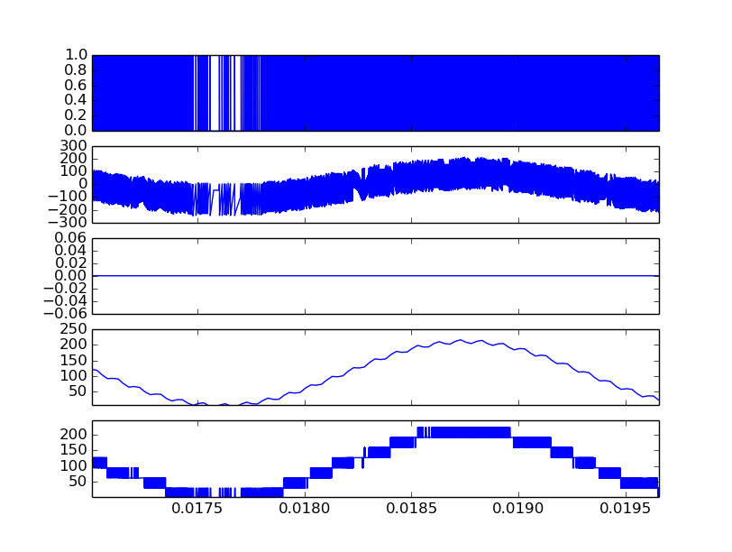
(1) DAC Quantized Output, (2) Integrator Output (no overflow shown in (3)), (4) input, 440Hz 80% 8bit ampltiude, 10kHz 5% amplitude, and (5) DAC output low-pass filtered through 8-window average.

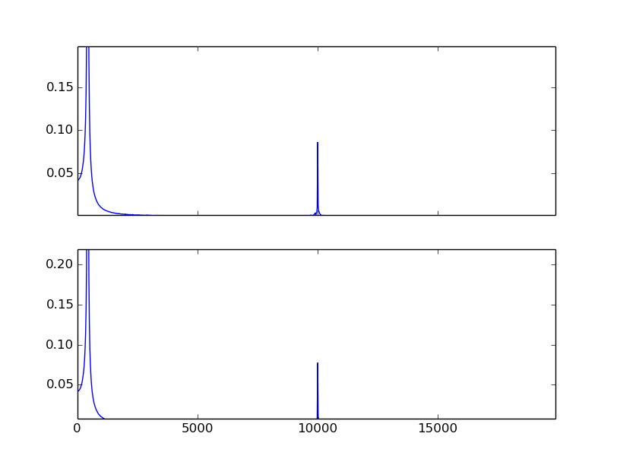
(1) FFT of input, (2) FFT of output in audible rang 0 -20kHz. All harmonics seem pushed out past audible range, so I guess they were sampling artifacts, and we see error in 10khZ amplitude from 0.087 to 0.079, normalized to 440Hz peak (1 in both cases). So relative error is something like 0.008/0.08 ~ 10% from DACIN to DACOUT, unfiltered.

Filter will add phase delay as well, mind you – and gain skew possibly. But testing what it sounds like,
the input is clean enough, well oversampled, and the output is.. well, oversampled at 64x40kHz = 2.56MHz, which is easy enough to do with a Nexus 2 50MHz board, but hard to play on my laptop speakers. So I imported into Audacity and LPFd with a cutoff at 20khz and a rolloff of 48dB/octave, and we get this fantastic looking wave where I can't even see the sample points. Just looking at the FFT it's clear there's almost no noise in the audible band due to the DAC – though our 10% 10kHz amplitude error might disagree.. the point is, it'll sound fine, and now the only thing to check is.. can I even hear a 5% amplitude wave?

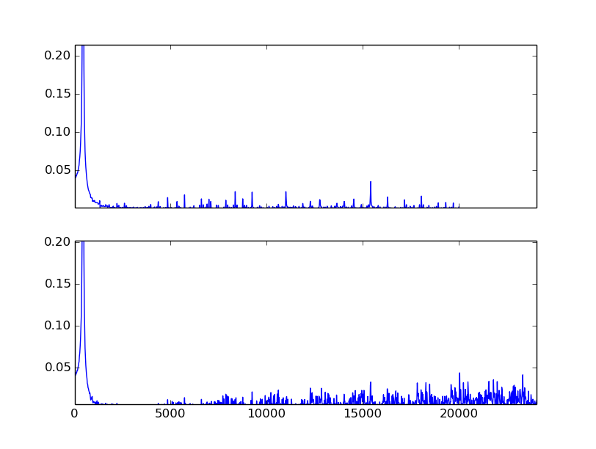
This is the FFT of the input/output wave from our DAC for an 440Hz input sampled the same as before. Only now the 440Hz wave instead of having 80% of 8bit amplitude has 5% (0-13). Now we see the noise that was likely rounded away before in the audible range. Or maybe generated anew? The high frequency noise (well outside audible range) is VERY high (40% of LF peak) which is .. bad, that's a lot of MHz noise in my FPGA. Oops. Maybe it won't matter. Worst case I change my DAC to increase L and decrease K.

Notice here, that if we assume the old example just didn't see the noise due to roundoff error, we're not acually at 0 noise when one of the signals is really high, we're closer to.. 0.1 vs 0.02 or 5x SNR at 10kHz, so for now, let's remove anything below 5kHz, but keep the old amplitudes, 0.8 and 0.05, and try again, and see if the same noise shows up. That tells us something about our true SNR, because in actuality we expect a fair amount of background noise regardless so maybe the input amplitude will never stay quite so low. Ok, fine, try that, then try a vocal recording, changed to 8 bit, and run through the DAC, and then we'll know what a real sound might get processed as.

Going to do the same as the first test but normalize by 10kHz peak to get us down to the 20% FFT amplitudes we saw before. That'll show us the noise well.

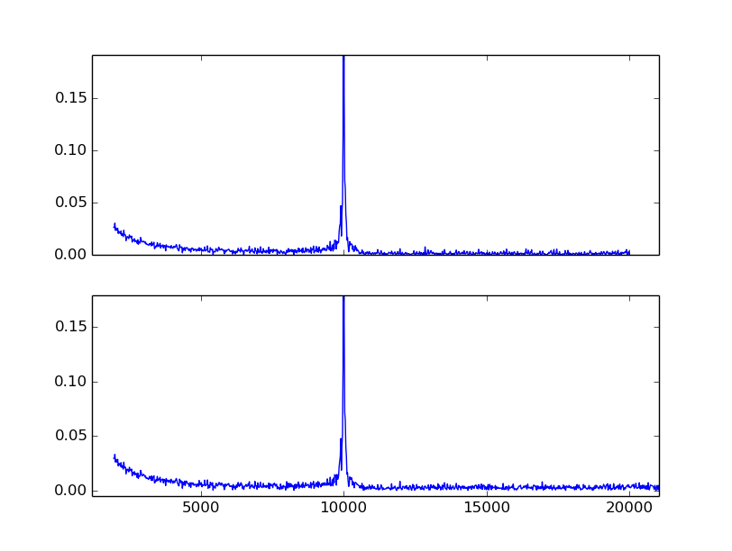
So.. when there's a large amplitude 440Hz signal, the 10K is well above noise, even with 5% amplitude. Here, above I've cut away the specturm below about 5kHz and normalized by the 10K peak.

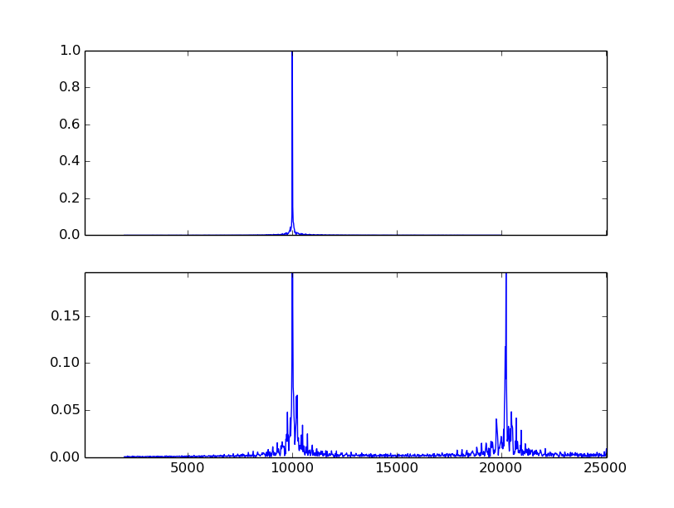
Then I tried removing the 440Hz and keeping the 10K at 5% amplitude ,again, to check – with the same normalization of 10K peak. That doesn't look nearly as bad as the last time.. with 440Hz at 5% amplitude, we were seeing 2.5% of the 440Hz peak in noise here. Given that the 10k signal at 5% is close to 10% of the 440Hz peak, this means now, at 5% 10k signal, without the 440Hz peak,we're seeing 5% noise but only very close to the band. Otherwise it's tiny, near 10% of 2.5% or 0.25% as we'd expect. Also there's a large near-audible harmonic! Why.. weird.. now suppose I increase the 10k signal to 2x or 10% amplitude...

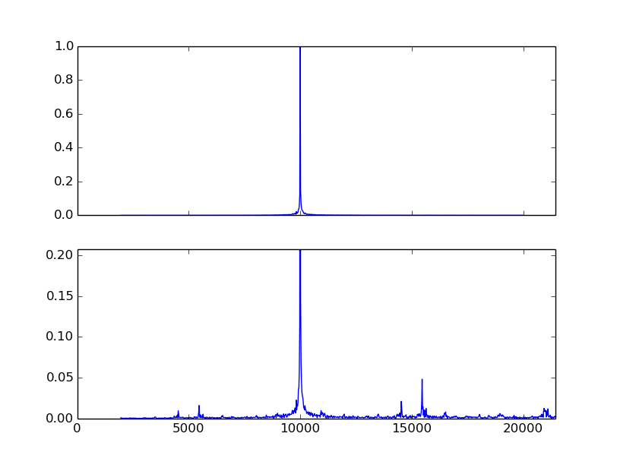
and all of a sudden at 10% 10k amplitude we see the noise drop way down and the harmonics shift. This is really strange. Hm.. maybe I had the axes wrong on the 80-5 first plot. Let's try that again.

Nope – tiny, tiny error. The lesson: higher amplitude overall signals preserve the spectrum better. Even if it's the same signal.. shifted up? Let's try that!

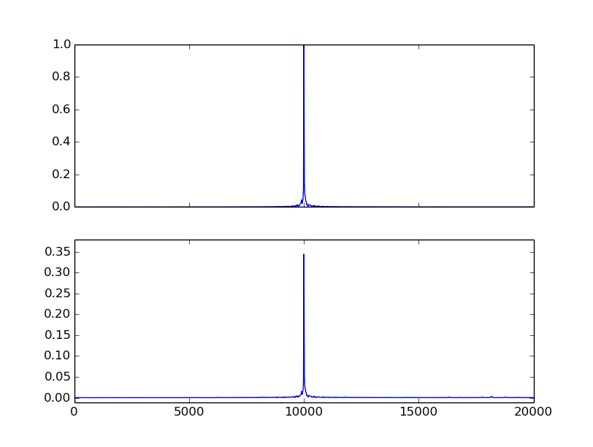
Yep: just offsetting a 0-13 signal by 20, so it's 20-33, changes the FFT so there's again barely any noise.
So the amplitude, the fraction of time spent away from 0, is what matters. The DAC is very sensitive around 0. Why? For another time – now we know we want to offset our output signals and restrict our range, for better noise reduction.

Actually, wait – if I'm near either extreme, the things I add/sub are also near the extremes, so I'll see large oscillation relative to my value, and so I'll have to switch very, very fast. That introduces HF components, and also means my error will be a bit larger. If I'm nearer the middle, the 'swaps' up and down are not so far from my true value. The edges are really the worst. So having higher amplitude signals puts our average noise lower. Ok. That's one theory.

Ok, now try real audio, see if it captures things well. Take 16 bit signed input, normalize to 0-255.

See wav2list.py – and 8bitsIsPlenty/
It sounds the same to me. We're a go on DAC:

Decisions: DAC, K = 64, L = 1, Fs = 40000k, 2.56MHz oversampled integrator, 8 bits + 1,2 (both work) extension bits + 1 sign bit for integrator, follow dac.py in the h/w design. Need Mhz 2- 8-10 bit adders and comparison. Finding a way to efficiently introduce a safe offset into the DAC input is important. Maybe.. start with 0-255, extend to 0-512, offset from both sides, and proceed with a 9bit + extensions adder. Then my op-amp at the other side is wasting a lot of its range, half, actually, but it's ok, less noisy in audible range. Cost is size, minimal, but gain is way less noise from my L = 1 DAC.

Ok, NOW: switch to LMS – ADC last.

5/26/2015

Let's try this with Spice.

